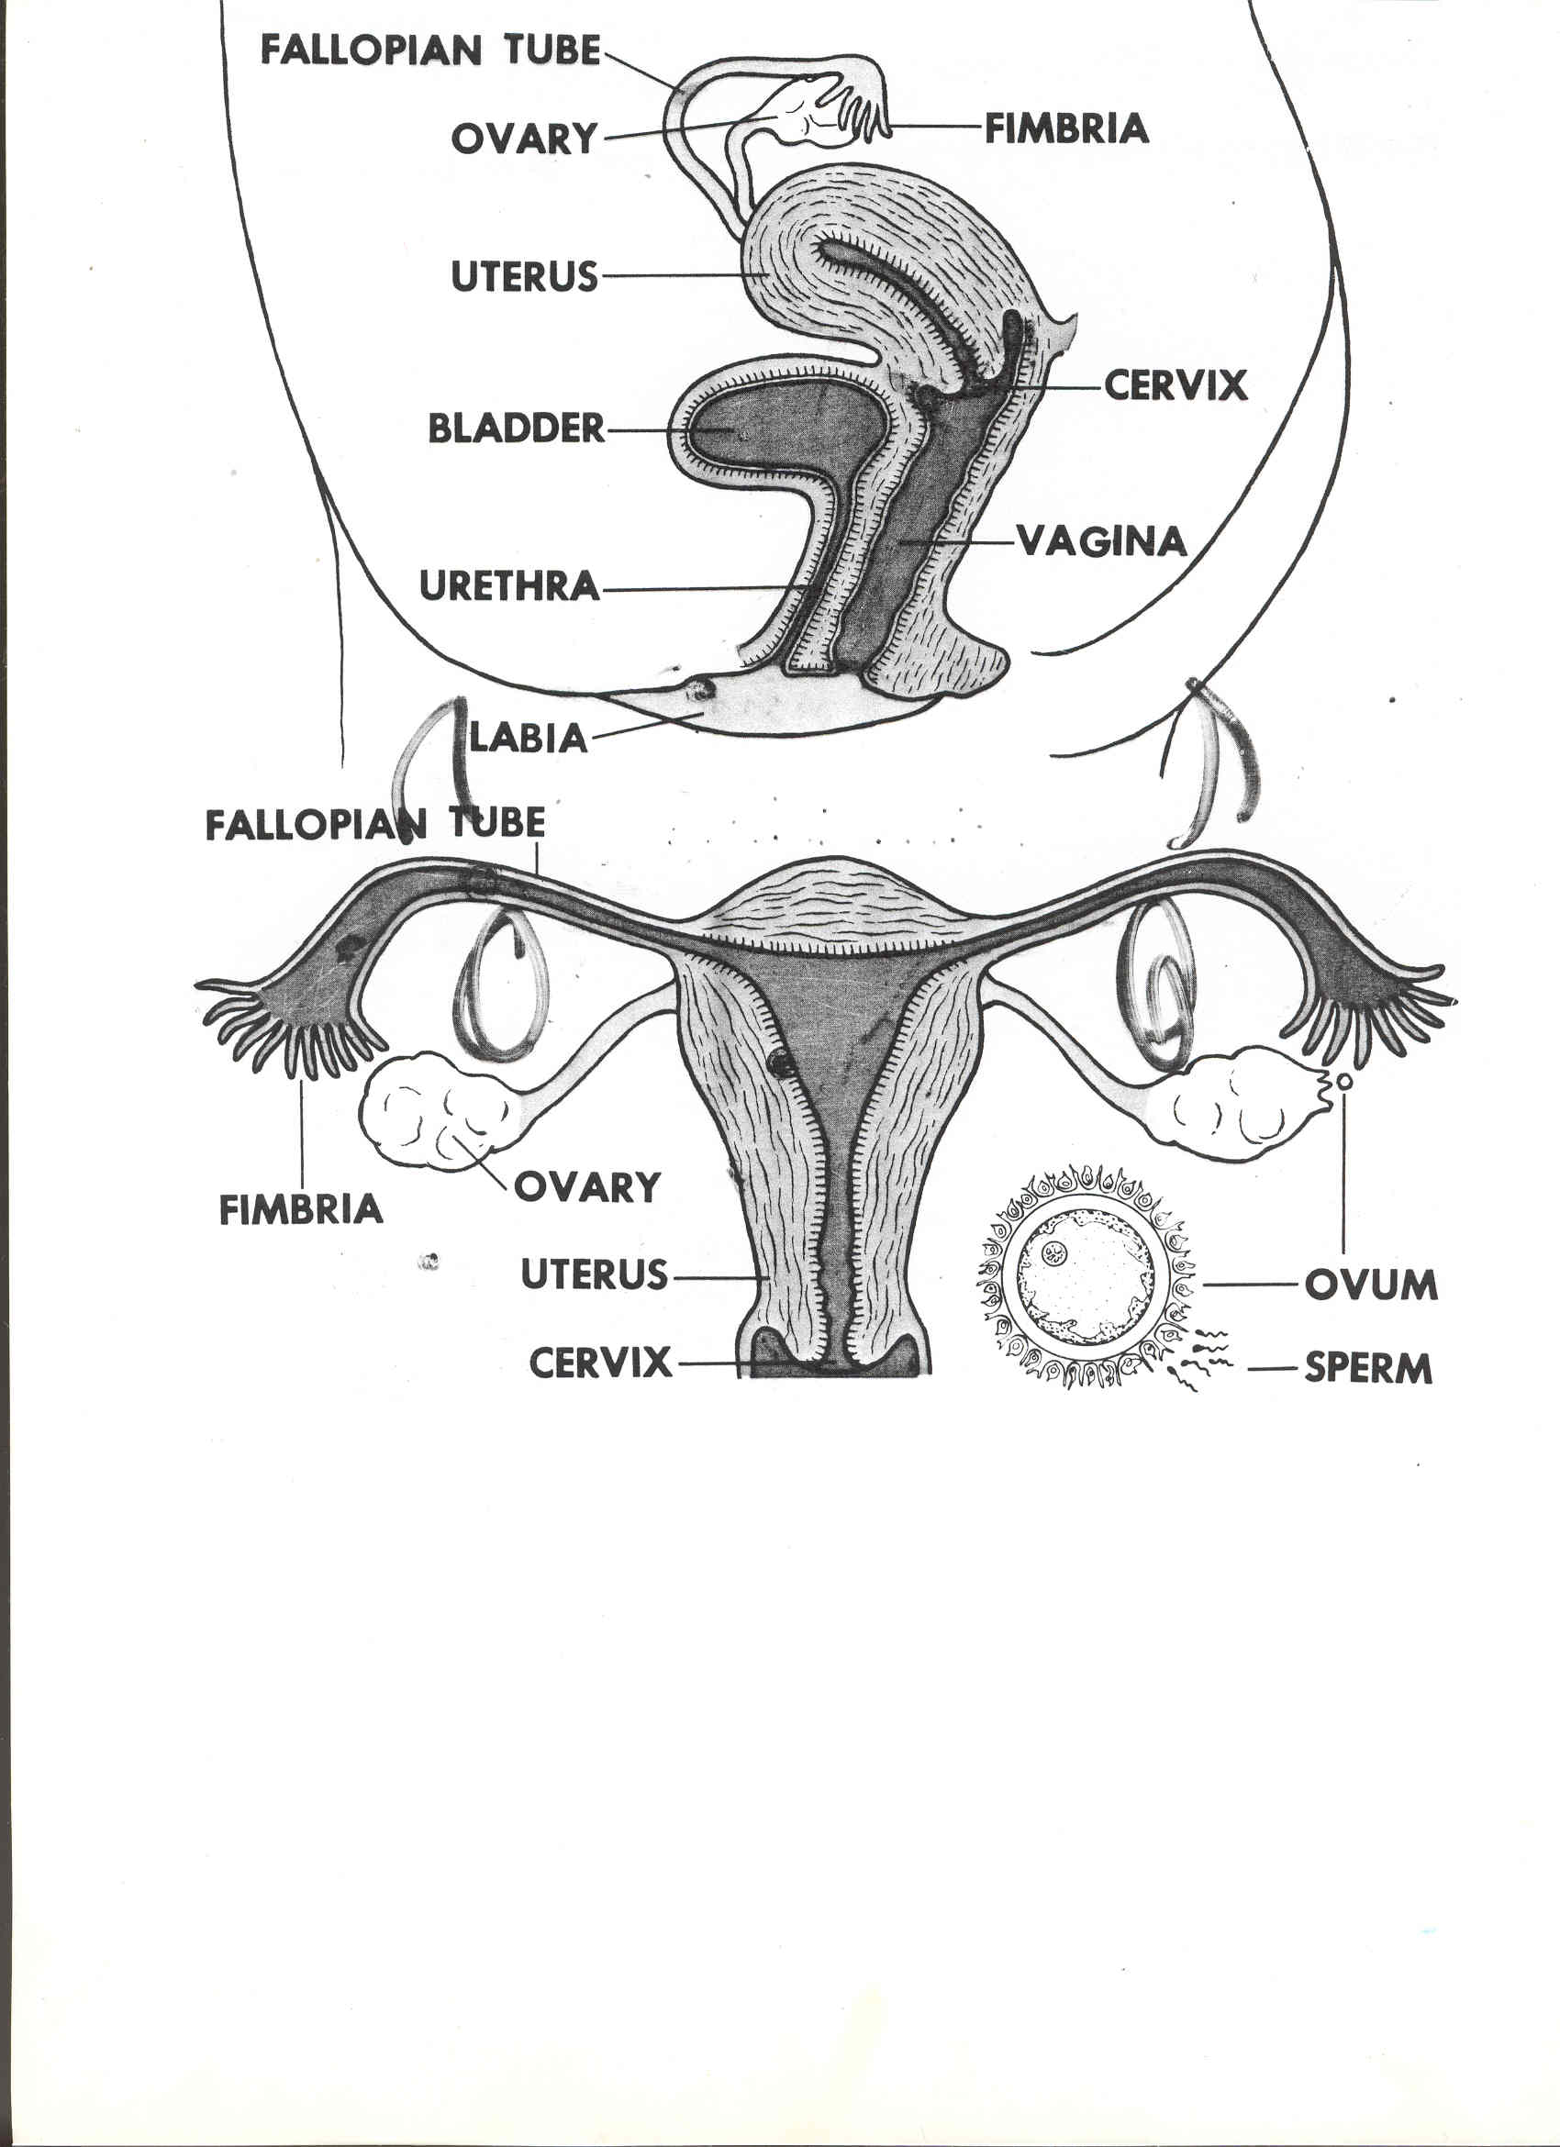
1.
Ovaries
Fimbria
Uterus
4. Bladder
8. Cervix
Urethra
Vagina
Hymen
6. Labia folds
Name: Date:
Male-Female Reproductive Quiz Health

In the numbered box, label the female diagram using the word bank. Not all words will be used.

Fallopian tubes

Clitoris

WORD BANK
Bladder Fallopian Tubes Fimbria Clitoris
Cervix Hymen Labia Folds Urethra
Vagina Uterus Ovary Ovum

#11. ___G_ ovary a. fertilization usually occurs here

#12. ___I_ uterus b. female sex cell

#13. __A__ Fallopian tube c. opening to the uterus

#14. __C__ cervix d. also known as the birth canal

#15. __D__ vagina e. release of the ovum from the ovaries

#16. __E__ ovulation f. discharge of the lining of the uterus

#17. __F__ menstruation g. produce estrogen and the female sex cell

#18. _H___ estrogen h. female hormone

#19. __B__ ovum i. muscular organ that expands during pregnancy

#20. _J__ urethra j. tube that carries urine out of the body

In the numbered box, label the male diagram using the word bank. Not all words will be used.
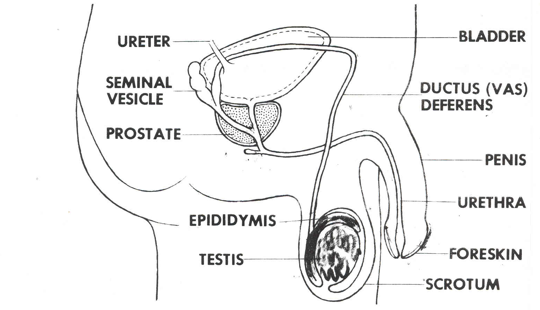
25. Bladder
Vas deferens
Scrotum
29.Foreskin
28.Urethra
Penis
Seminal vesicle
22.

Ureter

Prostate

Cowper’s gland

23.Epididymis

24.Testicle

WORD BANK
Epididymis Bladder Penis Foreskin
Cowper’s Gland Ureter Urethra Scrotum
Prostate Gland Testicle Seminal Vesicle Vas Deferens

#31. _F___ scrotum a. male sex hormone

#32. _G__ testes b. total fluid of ejaculation

#33. _C___ vas deferens c. tube that carries sperm from the epididymis

#34. _D___ foreskin d. skin covering the tip of the penis

#35. _B___ seminal vesicle e. surgical removal of the foreskin

#36. _E___ circumcision f. regulates temperature for sperm production

#37. A testosterone g. organ where sperm is produced

#38. __H__ semen h. adds fluid to sperm

#39. _J___ urethra i. male sex organ

#40. _I___ penis j. tube that carries urine out of the body

